Project Design Phase-II
Technology Stack (Architecture & Stack)
Date | 1 October 2026
Team ID | SWTID-2026-3491
Project Name | Import Data using Transform Maps (Spreadsheet)
Maximum Marks | 4 Marks

Technical Architecture:
The Deliverable shall include the architectural diagram as below and the information as per the table 1 & table 2
Example: Employee data import using Import Sets and Transform Maps in ServiceNow
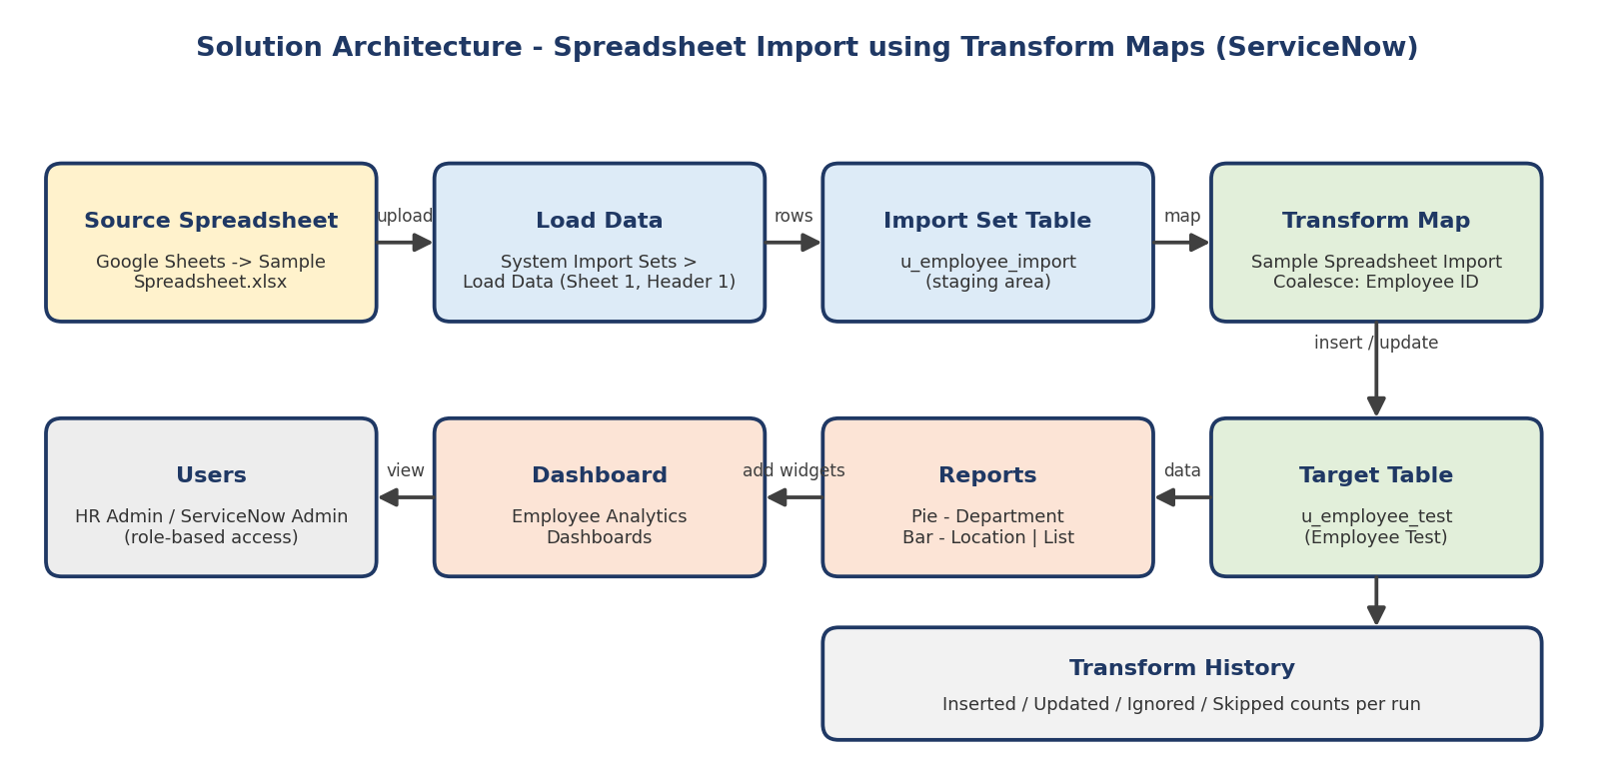

Table-1 : Components & Technologies:
S.No | Component | Description | Technology
1. | User Interface | How user interacts with application | ServiceNow platform UI (Application Navigator, forms, lists)
2. | Application Logic-1 | Loading spreadsheet rows into the staging table | Load Data / Import Set (u_employee_import)
3. | Application Logic-2 | Mapping and transforming staged rows into the target table | Transform Map "Sample Spreadsheet Import" with Auto Map and Mapping Assist
4. | Application Logic-3 | Duplicate prevention on repeat imports | Coalesce on Employee ID field map
5. | Database | Employee Import (staging) and Employee Test (target) tables with String fields | ServiceNow relational database
6. | Cloud Database | Database service on cloud | ServiceNow cloud instance
7. | File Storage | Source spreadsheet attached at import | Sample Spreadsheet.xlsx uploaded through Load Data
8. | External API-1 | Not used in this project | N/A
9. | External API-2 | Not used in this project | N/A
10. | Machine Learning Model | Not used in this project | N/A
11. | Infrastructure (Server / Cloud) | Application deployment on cloud | ServiceNow cloud instance (no local server required)

Table-2: Application Characteristics:
S.No | Characteristics | Description | Technology
1. | Open-Source Frameworks | Spreadsheet prepared in Google Sheets / Excel; platform itself is ServiceNow | Google Sheets, Microsoft Excel (.xlsx)
2. | Security Implementations | Role-based access; ACL on pa_dashboards (Create) with Admin Overrides; reports shared with chosen users, groups and roles | ServiceNow ACLs, roles, Share options
3. | Scalable Architecture | Staging-table pattern separates loading from transformation, so large spreadsheets can be processed in bulk | Import Sets + Transform Maps
4. | Availability | Hosted on the ServiceNow cloud instance, accessible from any browser | ServiceNow cloud
5. | Performance | Coalesce ignores unchanged rows (4 rows ignored on identical re-import); Transform History shows inserted / updated / ignored counts | Transform Map, Transform History

References:
- https://c4model.com/
- https://www.ibm.com/cloud/architecture
- https://aws.amazon.com/architecture

